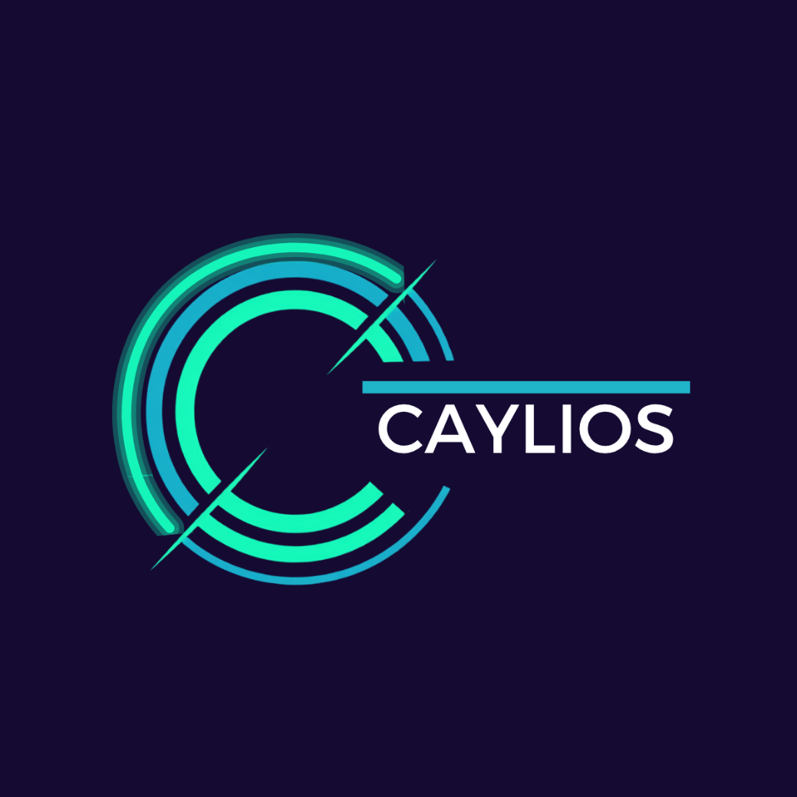

VISUAL LANGUAGE GUIDE

8 July 2026
BY KYLIE STEWART

Table of Contents
Table of Contents 2
Document Information 4
Purpose 4
Version Control 4
Introduction 5
Design Principles 6
Core principles 6
Layout System 7
Grid System 7
Principles 7
Spacing System 7
Alignment 7
Rules 8
White Space 8
Layout Types 8
Layout Principles 8
Examples 9
Information Hierarchy 10
Hierarchy Levels 10
Visual Priority 10
Grouping 10
Progressive Disclosure 11
Hierarchy Test 11
Diagram Standards 12
Design Philosophy 12
Diagram Principles 12
Structural Rules 12
Flow Direction 12
Connectors 13
Labelling 13
Diagram Test 13
Future Examples 13
Component Library 15
Key components 15
Component Principles 15
Rules 15
Examples 16
Shape Library 17
Rules 17
Usage 17
Shape Definition Principles 17
Shape Legend 18
Icon System 19
Design Philosophy 19
Construction Principles 19
Usage 19
Usage Rules 20
Colour 20
Accessibility 20
Relationship 20
Icon Set 21
Graphic Elements 23
Usage 23
Usage Rules 23
System Intent 24
Templates 25
Template Types 25
System Integration 25
Usage Principles 25
Constraint 26
System Intent 26
Relationship 26

Document Information

Purpose
This document defines the visual system for Caylios. It establishes how information is structured, represented, and communicated across all visual materials, ensuring consistency, clarity, and scalability as the business grows.
This visual system operates in alignment with the Caylios Brand Kit, which defines the overarching brand, messaging, and communication principles.
It translates the Caylios brand into a set of visual rules that guide how layouts, diagrams, components, icons, and supporting design elements are used in practice.
It exists to:
- Ensure all visual communication is consistent and recognisably Caylios
- Provide a structured system for designing documents, presentations, and visual materials
- Reduce inconsistency and subjective design decisions
- Ensure complex ideas are communicated in a clear, structured, and repeatable way
- Support the ongoing scaling of Caylios through a unified visual system

Version Control
VERSION | PURPOSE | DISTRIBUTED | DATE
0.01 | Draft | Internal
0.02 | Name update and completed draft | Internal | 6 July 2026
0.03 | Further refinements for approval | Directors | 8 July 2026
1.0 | FINAL with exception of examples | Directors

Introduction
This document is used as the reference point for all visual design decisions across Caylios materials. It should be applied when creating or reviewing any layout, diagram, component, or visual structure.
In the event of conflict, the Caylios Brand Kit takes precedence over this document.

Design Principles
Caylios visual design exists to make information easier to understand.
Every visual decision should reduce cognitive effort, communicate structure, and support confident decision-making. Visual elements exist to explain systems, not decorate them.
The visual language should reflect the same principles that underpin the Caylios platform: simplicity, consistency, structure, and continuous improvement.
Visual communication should always prioritise clarity over creativity.

Core principles
Clarity First | Every visual element must make information easier to understand. If it does not improve comprehension, it should be removed
Structure Before Styling | Layout, alignment and hierarchy communicate more effectively than decorative styling. Structure should always lead visual design.
Hierarchy Is Non-Negotiable | The most important information should always be immediately obvious through placement, size and spacing.
Consistency Creates Confidence | Reusing familiar layouts, components and patterns reduces cognitive effort and makes information easier to navigate.
Function Before Aesthetics | Every visual element must have a purpose. Design exists to support communication, not decoration.
Technology Without Theatre | Visual design should communicate practical business improvement rather than technology for its own sake. AI, automation, and digital capabilities should be represented as enabling systems, not as the primary visual identity.
Reduce Cognitive Load | Present only the information required to understand the message. Remove unnecessary complexity wherever practical.
Design For Reuse | Create reusable visual components before creating one-off designs. Every asset should contribute to the Caylios visual system.
Everything Earns Its Place | Every icon, shape, colour, line and component should exist because it improves communication. Nothing should be included purely for decoration.
Familiar meaning. Consistent execution. | Leverage established visual conventions wherever practical. Distinguish Caylios through consistent construction and application, not by reinventing what users already understand.

Layout System
The Layout System defines how information is organised across all Caylios visual materials. It establishes a consistent structural framework that improves readability, reinforces hierarchy, and creates a predictable experience across documents, presentations, platform interfaces, and marketing materials.
Every layout should guide the viewer naturally through information while minimising cognitive effort.

Grid System
All Caylios layouts are built on a consistent underlying grid.
The grid provides the structural framework that aligns content, creates balance, and ensures visual consistency across every application.

Principles
- Use a consistent column grid appropriate to the medium.
- Align all content to the grid.
- Avoid arbitrary positioning.
- Maintain consistent margins.
- Use the grid to create rhythm rather than decoration.

Spacing System
Spacing is one of the primary tools used to communicate relationships between information.
Consistent spacing improves readability and reduces visual clutter.
Spacing should communicate:
- relationships
- grouping
- separation
- hierarchy
Never use spacing simply to fill empty areas.

Alignment
Alignment creates order.

Rules
- Left alignment is the default.
- Maintain consistent vertical alignment.
- Align related objects.
- Avoid unnecessary centre alignment for body content.
- Avoid floating elements without structural alignment.

White Space
White space is an active design element.
Its purpose is to:
- separate ideas
- improve readability
- reduce cognitive load
- strengthen hierarchy
White space should never appear accidental or excessive.

Layout Types
LAYOUT | PURPOSE
Single Column | Reports, policies, procedures
Two Column | Comparisons, supporting information
Three Column | Feature summaries, marketing content
Dashboard | Metrics and operational visibility
Feature Layout | Website and presentations
Timeline | Sequential information
Process Layout | Workflow explanation

Layout Principles
Every Caylios layout should:
- communicate one primary message
- establish clear hierarchy
- minimise visual clutter
- remain predictable
- prioritise readability over decoration
- support reuse across multiple outputs

Examples
This is where I'd intentionally leave placeholders.
Eventually include:
- document page
- presentation slide
- dashboard
- proposal
- comparison page
- workflow overview

Information Hierarchy
Information Hierarchy defines how content is prioritised across all Caylios visual materials. It ensures viewers immediately understand what is most important, what supports it, and what provides additional detail.
Effective hierarchy reduces cognitive effort by allowing people to naturally scan, understand, and navigate information without unnecessary interpretation.

Hierarchy Levels
Level 1 | Primary message | The single most important idea within a page, slide, diagram, or section. It should immediately attract attention and establish context.
Level 2 | Supporting information | Expands, explains, or reinforces the primary message. It provides structure without competing for attention.
Level 3 | Detail | Supporting information, evidence, examples, notes, or explanatory content that adds depth once the primary message has been understood.

Visual Priority
Hierarchy should generally follow this order:
- Position
- Size
- Spacing
- Weight
- Colour
This sequence reinforces the Caylios principle of Structure Before Styling.

Grouping
Related information should be visually grouped.
Grouping may be achieved through:
- proximity
- spacing
- containers
- alignment
- consistent formatting
Groups should represent logical relationships rather than visual decoration.

Progressive Disclosure
Complex information should be introduced progressively.
Present information in layers:
- Summary
- Explanation
- Detail
This reduces cognitive load and supports faster decision-making.

Hierarchy Test
A simple validation exercise:
When reviewing any visual, ask:
- Can the primary message be understood in under five seconds?
- Is the next level of information immediately obvious?
- Does any secondary content compete with the primary message?
- Can unnecessary detail be removed or deferred?
If hierarchy is working well, viewers should naturally know where to look next without conscious effort.

Diagram Standards
The Diagram Standards define how systems, workflows, architectures, relationships, and operational concepts are visually represented across all Caylios materials.
They ensure diagrams communicate complex information in a structured, consistent, and immediately understandable way while maintaining alignment with the Caylios visual system.
Diagrams exist to simplify complexity, not increase it.

Design Philosophy
Every Caylios diagram should communicate a single idea as simply as possible. A diagram should communicate its primary message with minimal explanation. Where possible, the diagram should be understandable without supporting narrative.

Diagram Principles
Every diagram should be:
PRINCIPLE | MEANING
Simple | Remove unnecessary visual complexity.
Structured | Follow a clear logical arrangement.
Consistent | Use approved shapes, icons and connectors only.
Reusable | Diagram structures should be reusable across different contexts.

Structural Rules
Every diagram should
- communicate one primary concept
- have a clearly defined starting point (where applicable)
- establish an obvious reading direction
- group related elements logically
- minimise connector crossings
- maintain consistent spacing
- align to the Caylios grid system

Flow Direction
Unless there is a compelling reason otherwise:
- Left → Right for operational workflows
- Top → Bottom for hierarchies
- Circular for lifecycle models
- Hub → Spoke for platform relationships
Avoid changing reading direction within the same diagram.

Connectors
Connectors represent relationships.
Rules:
- Use consistent line weight.
- Avoid unnecessary bends.
- Minimise crossings.
- Maintain equal spacing.
- Arrowheads should indicate direction only when required.

Labelling
Labels should:
- be concise
- use consistent terminology
- avoid unnecessary sentences
- align with the Caylios Definition of Terms where applicable

Diagram Test
Before approval, every diagram should answer:
- Can the main message be understood in under 10 seconds?
- Is the reading direction obvious?
- Are related concepts grouped together?
- Could any element be removed without reducing understanding?
- Would someone unfamiliar with the topic understand the structure?

Future Examples
Instead of only rules, include one page for each approved diagram type:
- Process Flow
- Workflow
- Decision Tree
- System Architecture
- Platform Architecture
- Lifecycle
- Feedback Loop
- Governance Model
- Hub & Spoke
- Swimlane

Component Library
The Component Library defines a set of reusable visual building blocks used across all Caylios materials. Components are pre-defined structures that can be combined to build layouts, presentations, documents, and digital outputs without redesigning from scratch.

Key components
COMPONENT | PURPOSE
Content Blocks | Presents related information in a structured section.
Process Steps | Represents a single activity within a process or workflow.
KPI / Metric Cards | Highlights a single measurable value or performance indicator.
Callout Sections | Draws attention to important information, warnings or recommendations.
Before / After Comparison Blocks | Compares the current and future state or two alternative approaches.
Step-By-Step Modules | Presents sequential instructions or phased activities.

Component Principles
Components should:
- communicate one purpose only
- remain visually simple
- be reusable across multiple formats
- align to the Caylios Layout System
- support the Information Hierarchy
- avoid unnecessary visual variation

Rules
- Components must be reused consistently across all Caylios materials.
- No new component structures should be created outside this system.
- Components must be adaptable across different formats (deck, document, digital).
- Each component must have a single clear purpose.
- Components must maintain alignment with the layout system and hierarchy rules.
- Components should be designed for reuse before new components are created.

Examples
Examples will be provided for each approved component as the Caylios component library evolves.
Initially, the Component Library defines component standards rather than individual component specifications.
That gives you somewhere to grow into without having to design dozens of components today.

Shape Library
The Shape Library defines the approved set of shapes used to construct Caylios diagrams and system visuals. It provides a consistent visual language for representing processes, decisions, data, documents, and system relationships across all Caylios materials.
A shape legend defines all approved shapes and serves as the single source of truth for process mapping across Caylios. All diagrams must be built using only shapes from this legend.

Rules
- Only shapes defined in the Caylios shape legend may be used
- Each shape must represent a single, consistent meaning
- Shapes must not be modified, combined, or redesigned
- No new shapes may be introduced outside the approved legend
- All diagrams must remain consistent with Caylios diagram standards
- Shape meaning must be understandable without additional explanation

Usage
- Shapes are used to construct:
  - Process maps
  - Workflow diagrams
  - System architecture diagrams
  - Concept models
- Shapes define structure, logic, and flow within systems
- The shape legend must be referenced for all diagram creation

Shape Definition Principles
A shape represents its defined purpose regardless of context. The meaning of an approved shape must remain consistent across all Caylios diagrams. Shapes must not be repurposed to represent different concepts.

Shape Legend
Name | DESCRIPTION | Shape
Start / End | Represents the beginning or end of a process or workflow. Defines process boundaries.
Process | Represents a single step or activity within a workflow where work is performed or progressed.
Predefined Process | Represents a subprocess or set of steps that is defined elsewhere and reused within the workflow.
Document | Represents a single document, file, form, or information output used or produced in a process.
Multiple Documents | Represents multiple documents or grouped document outputs within a process.
Decision | Represents a decision point where the process follows one of multiple possible paths based on a condition.
Data | Represents raw data, inputs, or information entering or being used within a process.
Data Storage | Represents a system or location where data is stored, held, or retrieved.
Manual Input | Represents information or data that is manually entered by a person into a system or process.
Manual Operation | Represents a physical or manual action performed by a person outside of automated systems.

Icon System
The Icon System defines the visual language, construction principles, and usage rules for all icons used across Caylios materials. Icons provide a consistent visual shorthand that improves recognition, reinforces information hierarchy, and supports clear communication across documents, presentations, diagrams, and digital interfaces.
Icons should simplify understanding, not decorate content.

Design Philosophy
Caylios icons represent functions, relationships, and systems rather than detailed illustrations. They should feel:
- Simple
- Structured
- Precise
- Modern
- Consistent
Icons should communicate meaning immediately while remaining visually understated.

Construction Principles
All icons should:
- be designed using the approved Caylios icon construction standard
- maintain consistent visual weight
- use consistent proportions
- remain recognisable at small sizes
- avoid unnecessary detail
- align with the Caylios visual language

Usage
Icons may be used to support:
- Navigation
- Diagrams
- Dashboards
- Documents
- Presentations
- Marketing material
- Digital interfaces
Icons should reinforce information, not replace clear written communication.

Usage Rules
Icons must:
- represent a single, clearly defined concept
- maintain a consistent meaning across all applications
- be used consistently throughout Caylios materials
- support the Information Hierarchy
- align with the Layout System
Icons must not:
- replace headings or key information
- be used decoratively
- communicate multiple concepts
- mix different icon styles within the same output

Colour
Icons should normally use approved Caylios brand colours.
Accent colours may be used only where they improve communication or indicate system status.

Accessibility
Icons should never be the only method of communicating important information.
Where meaning is critical, icons should be supported by labels or surrounding context.

Relationship
The Icon System defines how icons are designed and used.
The approved Icon Library contains the individual icons available for use across Caylios materials.

Icon Set
 | DESCRIPTION | Icon
Caylios Capability
Understand | Analyse the current state to identify operational friction, gaps, and opportunities for improvement. | 
Improve | Refine existing processes to reduce inefficiency and improve how work moves through the business. | 
Structure & Organise | Organise information, processes, and responsibilities into clear, repeatable systems.
Automate | Replace manual activities with automated workflows to improve efficiency and consistency. | 
Implement | Deploy and embed new processes, systems, or solutions into everyday operations.
Platform | Represents the Caylios platform or an integrated business system supporting operational delivery.
Workflow
Process | Represents a defined business process or workflow.
Workflow | Represents the movement of work between activities, people, or systems.
Decision | Represents a decision point where a process follows one of multiple possible paths.
Manual Task | Represents work completed manually by a person.
Automation | Represents an automated action or system-driven process.
Information
Document | Represents a document, file, form, or report used within a process.
Database | Represents structured data or information stored within a business system.
Folder / Drive | Represents file storage, shared drives, or document repositories.
Dashboard | Represents reporting, operational visibility, or performance monitoring.
Report | Represents generated reports, summaries, or business outputs.
Application | Represents systems, tools, or application contexts used in work | Use proprietary icon
Communication
Message | Represents communication, notifications, or information exchanged between people or systems.
Email | Represents email communication or email-triggered activities.
Notification | Represents alerts, reminders, or system-generated notifications.
Outcomes
Capacity | Represents available operational capacity or resources created through process improvement.
Time | Represents time savings, faster delivery, or reduced effort.
Visibility | Represents improved transparency, monitoring, or operational insight.
Growth | Represents scalability, business growth, or increased capability.
Quality | Represents improved accuracy, consistency, or standardisation.
Efficiency | Represents reduced waste, improved productivity, and smoother operational performance.
Status
Success | Represents the successful completion of a task, process, validation, or operation.
Warning | Represents a condition requiring attention, review, or user awareness before proceeding.
Error | Represents a failure, exception, validation issue, or unsuccessful operation requiring correction.
Information | Represents supporting information, guidance, or contextual details that assist understanding.
Pending | Represents work, approval, or processing that has not yet been completed or resolved.


Graphic Elements
The Graphic Elements section defines the supporting visual elements used throughout the Caylios visual system. These elements reinforce the Caylios brand without competing with content, improving visual consistency across documents, presentations, digital products, and marketing materials.
Graphic elements are used to provide structure, emphasis, and visual continuity while ensuring readability and information hierarchy remain the priority.

Usage
Graphic elements may be used in:  - Website hero sections  - Presentation slides and pitch decks  - Brochures and marketing material  - Section dividers  - Background treatments  - Cards and content containers  - Infographics and supporting diagrams | 

Usage Rules
Graphic elements must:
- Support content rather than compete with it.
- Reinforce the Caylios visual identity.
- Maintain readability and information hierarchy.
- Be applied consistently across all materials.
- Remain subtle and secondary to the primary message.
Graphic elements must not:
- Replace or compete with brand marks or headlines.
- Obscure or reduce readability.
- Become the primary visual feature.
- Introduce unnecessary visual complexity.
- Use unrelated decorative patterns or textures.

System Intent
The Graphic Elements system exists to:
- reinforce the structured, modern, and system-driven character of the Caylios brand
- create visual consistency across all Caylios materials
- support content without distraction
- maintain a unified visual environment across formats
It should always remain subtle, embedded, and system-driven rather than decorative or attention-seeking.

Templates
The Template System defines the standard layouts used to create consistent Caylios documents, presentations, digital interfaces, and operational artefacts. Templates provide a reusable foundation that ensures information is presented consistently while reducing the need to redesign layouts for each new output.

Template Types
Caylios templates may include:
- Presentation templates (pitch decks, internal decks, client decks)
- Document templates (reports, proposals, strategy documents)
- Digital templates (web layouts, platform screens, UI structures)
- Operational templates (structured workflow documentation formats)
Each template is designed to support structured communication of information.

System Integration
All templates must be built using Caylios visual systems:
- Icon System (for meaning and visual cues)
- Shape Library (for process and logic diagrams)
- Graphic Elements (for visual environment)
- Component Library (for reusable layout structures)
Templates must not introduce new visual styles outside the Caylios system.
Templates combine approved Caylios visual systems into complete, reusable deliverables.

Usage Principles
All templates must:
- maintain consistent layout structure across all uses
- use Caylios-approved visual systems only
- be selected before new layouts are created.
- ensure information hierarchy is clearly structured
- prioritise clarity and readability over decoration
- remain adaptable across different content types
Templates are designed to support content, not override it.

Constraint
No template may:
- introduce new visual styles outside Caylios systems
- override or conflict with existing system rules
- deviate from defined layout structure
- prioritise aesthetics over clarity and function
All templates must remain consistent with the Caylios Visual Language Guide.

System Intent
The template system ensures that all Caylios outputs:
- feel structurally consistent
- follow a predictable information hierarchy
- align with Caylios visual systems
- can be produced efficiently without redesign
Templates represent the practical application of the Caylios visual system, ensuring visual standards are consistently implemented across all outputs.

Relationship
Templates are constructed using approved Caylios layouts, components, shapes, icons, and graphic elements. They do not define new visual standards but apply existing standards in a reusable format.

